Name: Akash Sah
PRN No: 202501120136
Division: DS2
Batch:D23
4.1.1. Pandas - series creation and manipulation
03:12
Write a Python program that takes a list of numbers from the user, creates a Pandas series from it, and then calculates the mean of even and odd numbers separately using the groupby and mean() operations.

Hint: You can group the Series based on whether each number is even or odd.

Input Format:
- The user should enter a list of numbers separated by space when prompted.

Output Format:
- The program should display the mean of even and odd numbers separately.
- Each mean value should be displayed with a label indicating whether it corresponds to even or odd numbers.

Refer to the sample test cases for better understanding regarding input and output format.
# import pandas as pd

# # Take inputs from the user to create a list of numbers
# numbers = list(map(int, input().split()))

# grouped =

# # Display the mean of even and odd numbers with labels
# grouped.index = ['Even' if is_even else 'Odd' for is_even in grouped.index]
# print("Mean of even and odd numbers:")
# print(grouped)
import pandas as pd

# Take inputs from the user to create a list of numbers numbers = list(map(int, input().split()))

# Create a Pandas series from the list of numbers s = pd.Series(numbers)

# Grouping by even and odd numbers and calculating the mean grouped = s.groupby(s % 2 == 0).mean()

# Display the mean of even and odd numbers with labels grouped.index = ['Even' if is_even else 'Odd' for is_even in grouped.index]

print("Mean of even and odd numbers:") print(grouped)
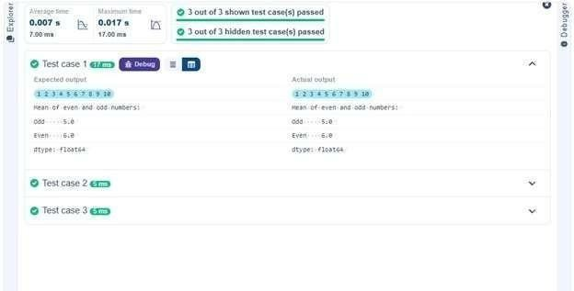
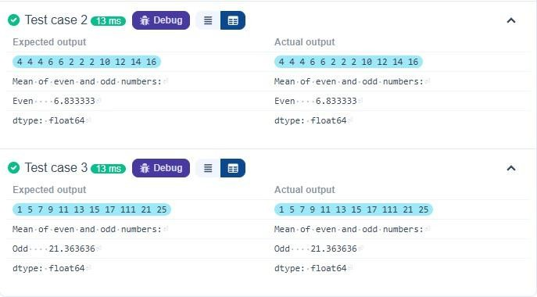

4.1.2. Dictionary to dataframe
07:26
A dictionary of lists has been provided to you in the editor. Create a DataFrame from the dictionary of lists and perform the listed operations, then display the DataFrame before and after each manipulation.

Create the DataFrame:
- Convert the dictionary to a Pandas DataFrame.

Add a new row:
- Take inputs from the user for the new row data (name, age).
- Add the new row to the DataFrame.
- Display the DataFrame after adding the new row.

Modify a row:
- Modify a specific row by changing the age. Take the row index and new age
value from the user.
- Display the DataFrame after modifying the row.

Delete a row:
- Take the row index to be deleted from the user.
- Remove the specified row.
- Display the DataFrame after deleting the row.

Add a new column:
- Add a column Gender with values taken from the user.
- Display the DataFrame after adding the new column.

Modify a column:
- Convert names to uppercase.
- Display the DataFrame after modifying the column.

Delete a column:
- Remove the Age column.
- Display the DataFrame after deleting the column. import pandas as pd

# Provided dictionary of lists data = {
'Name': ['Alice', 'Bob', 'Charlie'],
'Age': [25, 30, 35],
}

# Convert the dictionary to a DataFrame df = pd.DataFrame(data)

# Display the original DataFrame
print("Original DataFrame:") print(df)

# Adding a new row new_name = input("New name: ") new_age = int(input("New age: ")) df.loc[len(df)] =
[new_name, new_age]

# Display the DataFrame after adding a new row print("After adding a row:\n",df)

# Modifying a row row_to_modify = int(input("Index of row to modify: ")) new_age_value = int(input("New age: ")) df.at[row_to_modify, "Age"] = new_age_value
# Display the DataFrame after modifying a row print("After modifying a row:") print(df)
# Deleting a row row_to_delete = int(input("Index of row to delete: ")) df = df.drop(index=row_to_delete).reset_index(drop=True)

# Display the DataFrame after deleting a row print("After deleting a row:") print(df)

# Adding a new column genders_input = input("Enter genders separated by space: ") genders = genders_input.split()

# Ensure correct length if len(genders) == len(df): df["Gender"] = genders else:
print("Error: Number of genders must match rows!") df["Gender"] = ["Unknown"] * len(df)

# Display the DataFrame after adding a new column print("After adding a new column:")
print(df)

# Modifying a column df["Name"] = df["Name"].str.upper()

# Display the DataFrame after modifying a column print("After modifying a column:") print(df)

# Deleting a column df = df.drop(columns=["Age"])

# Display the DataFrame after deleting a column print("After deleting a column:") print(df)
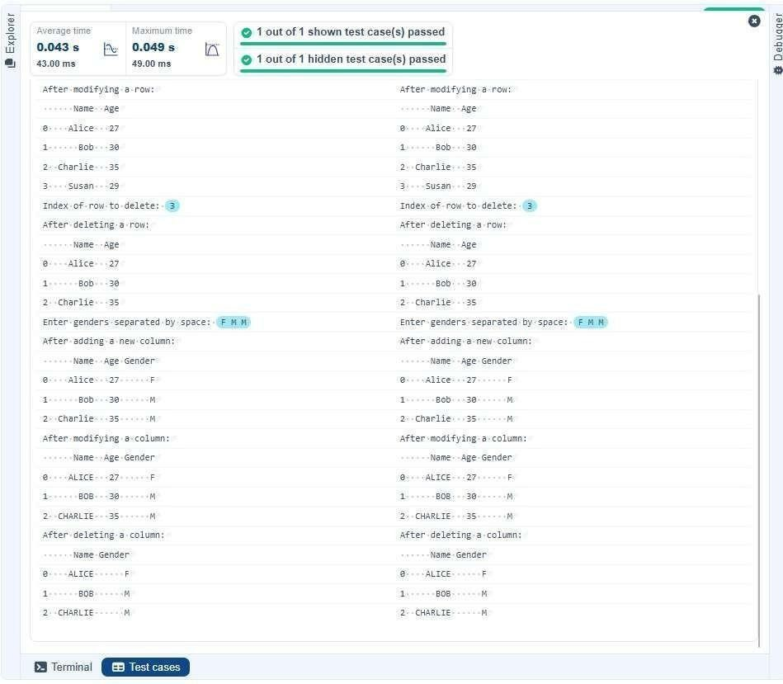
4.1.3. Student Information
01:49
Write a program to read a text file containing student information (name, age, and grade) using Pandas. Perform the following tasks:

- Display the first five rows of the data frame.
- Calculate the average age of the students (limit the average age up to 2 decimal places).
- Filter out the students who have a grade above a certain threshold (consider the threshold grade is 'B').

Note:
Refer to the displayed test cases for better understanding. import pandas as pd
# Read the text file into a DataFrame file = input() data = pd.read_csv(file, sep="\s+", header=None, names=["Name", "Age", "Grade"])
# Display the first five rows print("First five rows:") print(data.head())

# Calculate the average age (2 decimal places) avg_age = round(data["Age"].mean(), 2) print("Average age:", avg_age)

# Filter students with grade up to 'B' (A and B) filtered = data[data["Grade"].isin(['A', 'B'])]

print("Students with a grade up to B") print(filtered)

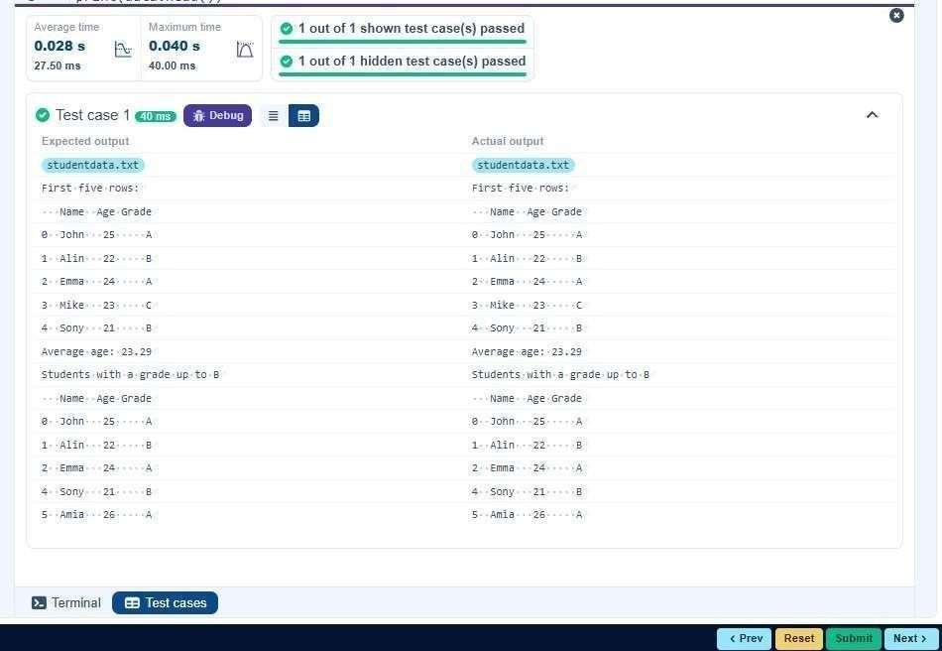

4.1.3. Student Information
01:49
Write a program to read a text file containing student information (name, age, and grade) using Pandas. Perform the following tasks:

- Display the first five rows of the data frame.
- Calculate the average age of the students (limit the average age up to 2 decimal places).
- Filter out the students who have a grade above a certain threshold (consider the threshold grade is 'B').

Note:
Refer to the displayed test cases for better understanding.
import pandas as pd

# Prompt the user for the file name file_name = input()

# Load the data df = pd.read_csv(file_name) # Prepare data for calculation df['Date'] = pd.to_datetime(df['Date']) df['Month'] = df['Date'].dt.to_period('M') df['Sales'] = df['Quantity'] * df['Price']

# Find the month with the highest total sales best_month = df.groupby('Month')['Sales'].sum().idxmax() highest_sales = df.groupby('Month')['Sales'].sum().max() print(f"Best month: {best_month}")
print(f"Total sales: ${highest_sales:.2f}")

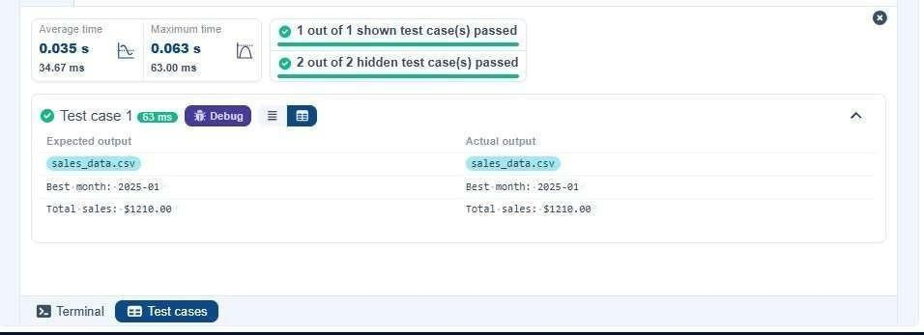

4.2.2. Best Selling Product 02:08 and performs the following operations:
Write a Python program that takes the file name of a CSV file as input, reads the data,

- The CSV file contains the columns: Date, Product, Quantity, Price, and City.
- Find the product that sold the most in terms of quantity sold.
- Display the product that sold the most and the total quantity sold for that product.

Sample Data:
Date,Product,Quantity,Price,City
2025-01-01,Product A,5,20,New York
2025-01-01,Product B,3,15,Los Angeles
2025-01-02,Product A,7,20,New York
2025-01-02,Product C,4,30,Chicago
2025-01-03,Product B,2,15,Chicago
2025-01-03,Product A,8,20,Los Angeles
2025-01-04,Product C,6,30,New York
2025-01-04,Product B,5,15,Los Angeles
2025-01-05,Product A,3,20,Chicago
2025-01-05,Product C,10,30,Los Angeles

Note:
The data cannot be displayed in the file. You can refer to the sample data provided for insights.
import pandas as pd

# Prompt the user for the file name file_name = input()

# Load the data df = pd.read_csv(file_name) # Find the product with the highest total quantity sold best_product = df.groupby('Product')['Quantity'].sum().idxmax() highest_quantity = df.groupby('Product')['Quantity'].sum().max()
# Display the result print(f"Best selling product: {best_product}") print(f"Total quantity sold: {highest_quantity}")
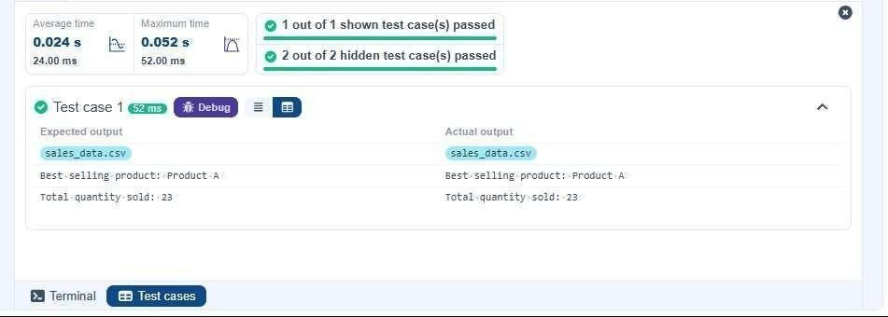

4.2.3. City that Sold the Most Products 01:45 and performs the following operations:
- The CSV file contains the columns: Date, Product, Quantity, Price, and City.
- Group the data by City and calculate the total quantity of products sold for each city.
- Find the city that sold the most products (based on the total quantity sold).

Sample Data:
Date,Product,Quantity,Price,City
2025-01-01,Product A,5,20,New York
2025-01-01,Product B,3,15,Los Angeles
2025-01-02,Product A,7,20,New York
Write a Python program that takes the file name of a CSV file as input, reads the data,

2025-01-02,Product C,4,30,Chicago
2025-01-03,Product B,2,15,Chicago
2025-01-03,Product A,8,20,Los Angeles 2025-01-04,Product C,6,30,New York
2025-01-04,Product B,5,15,Los Angeles
2025-01-05,Product A,3,20,Chicago 2025-01-
05,Product C,10,30,Los Angeles

Note:
The data cannot be displayed in the file. You can refer to the sample data provided for insights.
import pandas as pd

# Prompt the user for the file name file_name = input()

# Load the data df = pd.read_csv(file_name) # Group by City and calculate total quantity city_sales = df.groupby('City')['Quantity'].sum()

# Find the city with the highest total quantity sold best_city = city_sales.idxmax()

# Display the result print(f"City sold the most products: {best_city}")

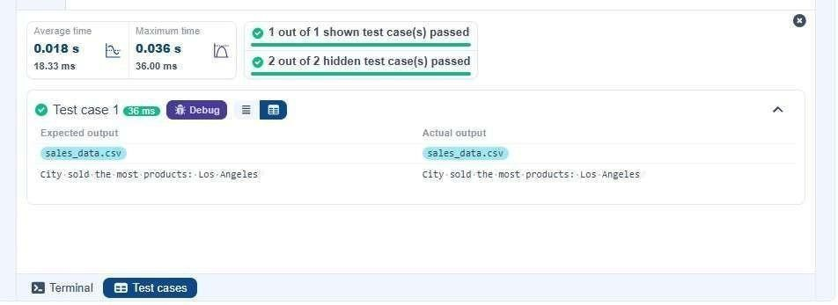

4.2.4. Most Frequently Sold Product Pairs
01:25

and performs the following operations:
- The CSV file contains the following columns: Date, Product, Quantity, Price, and City.
- For each date, find all pairs of products that were sold together (i.e., two products sold on the same date).
- Output the product pair/s that was sold most frequently.

Sample Data:
Date,Product,Quantity,Price,City
2025-01-01,Product A,5,20,New York
2025-01-01,Product B,3,15,Los Angeles
2025-01-02,Product A,7,20,New York
2025-01-02,Product C,4,30,Chicago
2025-01-03,Product B,2,15,Chicago
2025-01-03,Product A,8,20,Los Angeles 2025-01-04,Product C,6,30,New York
2025-01-04,Product B,5,15,Los Angeles
Write a Python program that takes the file name of a CSV file as input, reads the data,

2025-01-05,Product A,3,20,Chicago 2025-01-
05,Product C,10,30,Los Angeles
Explanation:
Transactions:
- 2025-01-01: Product A, Product B
- 2025-01-02: Product A, Product C
- 2025-01-03: Product B, Product A
- 2025-01-04: Product C, Product B 2025-01-05: Product A, Product C
Now, let's count how often the pairs of products appear together:
- Product A and Product B : Appear in transactions on 2025-01-01 and 2025-0103.
- Product A and Product C : Appear in transactions on 2025-01-02 and 2025- 0105.
- Product B and Product C : Appears in transactions on 2025-01-04.
Most Frequent Product Combinations:
- Product A and Product B (2 times)
- Product A and Product C (2 times)

Note:
The data cannot be displayed in the file. You can refer to the sample data provided for insights.

import pandas as pd

from itertools import combinations from collections import Counter

# Prompt user to input the file name file_name = input()

# Read data from the specified CSV file df = pd.read_csv(file_name) # write the code pair_counter = Counter()

# Group by Date and generate product pairs for _, group in df.groupby('Date'): products = group['Product'].tolist() pairs = combinations(sorted(products), 2) pair_counter.update(pairs)

# Find maximum frequency max_count
= max(pair_counter.values())

# Output the most frequent product pairs for pair, count in pair_counter.items(): if count == max_count:

print(f"{pair[0]} and {pair[1]}: {count} times")

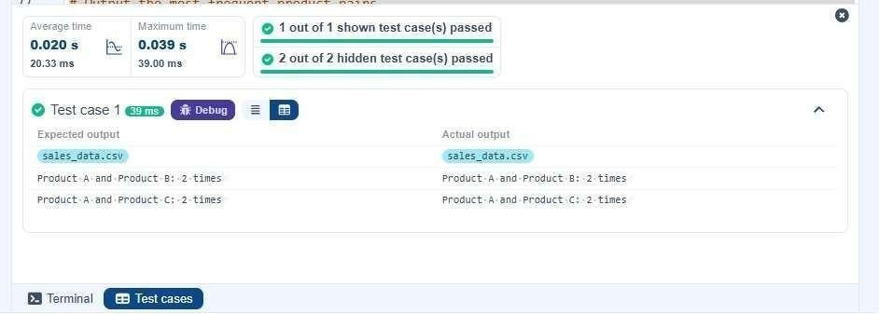
4.2.5. Titanic Dataset Analysis and Data Cleaning
01:36
You are provided with the Titanic dataset containing information about passengers on the Titanic. Your task is to write Python code to answer the following questions based on the dataset. For each question, perform necessary data cleaning, transformations, and calculations as required.

- Display the first 5 rows of the dataset.
- Display the last 5 rows of the dataset.
- Get the shape of the dataset (number of rows and columns).
- Get a summary of the dataset (using .info()).
- Get basic statistics (mean, standard deviation, etc.) of the dataset using .describe().
PassengerId | Survived | Pclass | Name | Sex | Age | SibSp | Parch | Ticket | Fare | Cabin | Embark
- Check for missing values and display the count of missing values for each column.

- Fill missing values in the ‘Age’ column with the median age.

- Fill missing values in the ‘Embarked’ column with the most frequent value (mode()).
- Drop the ‘Cabin’ column due to many missing values.
- Create a new column, 'FamilySize' by adding the 'SibSp' and 'Parch' columns.

The Titanic dataset contains columns as shown below,

Sample Data:
PassengerId,Survived,Pclass,Name,Sex,Age,SibSp,Parch,Ticket,Fare,Cabin,Embarked
1,0,3,"Braund, Mr. Owen Harris",male,22,1,0,A/5 21171,7.25,,S
2,1,1,"Cumings, Mrs. John Bradley (Florence Briggs Thayer)",female,38,1,0,PC
17599,71.2833,C85,C
3,1,3,"Heikkinen, Miss. Laina",female,26,0,0,STON/O2. 3101282,7.925,,S
4,1,1,"Futrelle, Mrs. Jacques Heath (Lily May Peel)",female,35,1,0,113803,53.1,C123,S
5,0,3,"Allen, Mr. William Henry",male,35,0,0,373450,8.05,,S
6,0,3,"Moran, Mr. James",male,,0,0,330877,8.4583,,Q
7,0,1,"McCarthy, Mr. Timothy J",male,54,0,0,17463,51.8625,E46,S
8,0,3,"Palsson, Master. Gosta Leonard",male,2,3,1,349909,21.075,,S
9,1,3,"Johnson, Mrs. Oscar W (Elisabeth Vilhelmina
Berg)",female,27,0,2,347742,11.1333,,S
10,1,2,"Nasser, Mrs. Nicholas (Adele Achem)",female,14,1,0,237736,30.0708,,C

Note: Refer to the visible test case for better reference.

import pandas as pd import numpy as np

# Load the Titanic dataset data = pd.read_csv('Titanic-Dataset.csv') # 1. Display the first 5 rows of the dataset print(data.head())

# 2. Display the last 5 rows of the dataset print(data.tail())

# 3. Get the shape of the dataset print(data.shape)

# 4. Get a summary of the dataset (info) print(data.info())
# 5. Get basic statistics of the dataset print(data.describe())

# 6. Check for missing values print(data.isnull().sum())

# 7. Fill missing values in the ‘Age’ column with the median age data['Age'] = data['Age'].fillna(data['Age'].median())

# 8. Fill missing values in the ‘Embarked’ column with the mode data['Embarked'] = data['Embarked'].fillna(data['Embarked'].mode()[0])

# 9. Drop the ‘Cabin’ column due to many missing values data = data.drop(columns=['Cabin'])

# 10. Create a new column 'FamilySize’ by adding ‘SibSp' and ‘Parch'
data['FamilySize'] = data['SibSp'] + data['Parch']

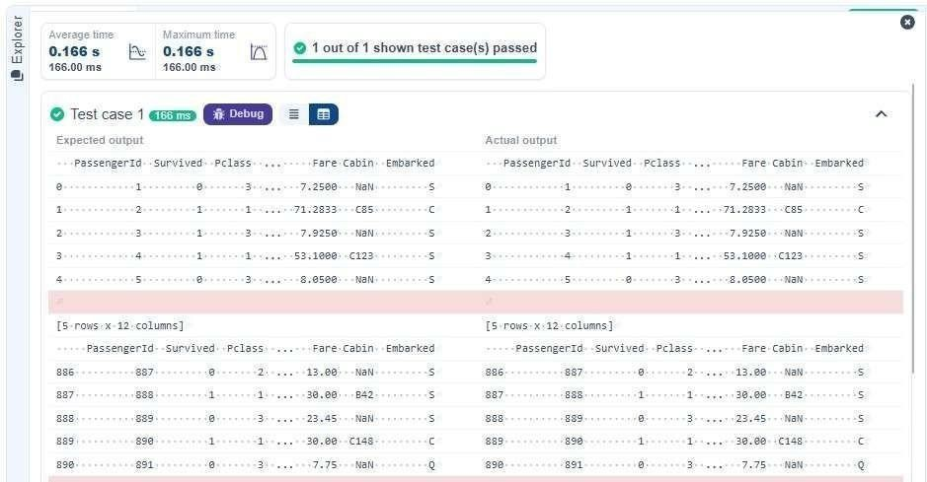

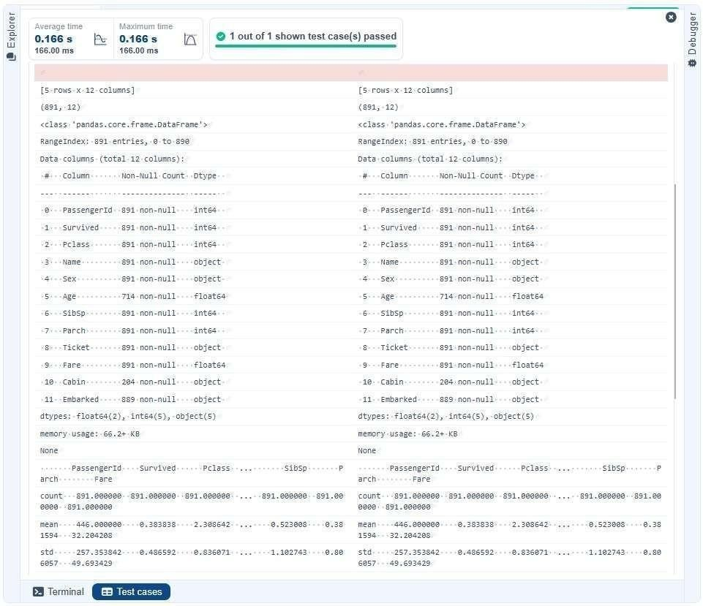
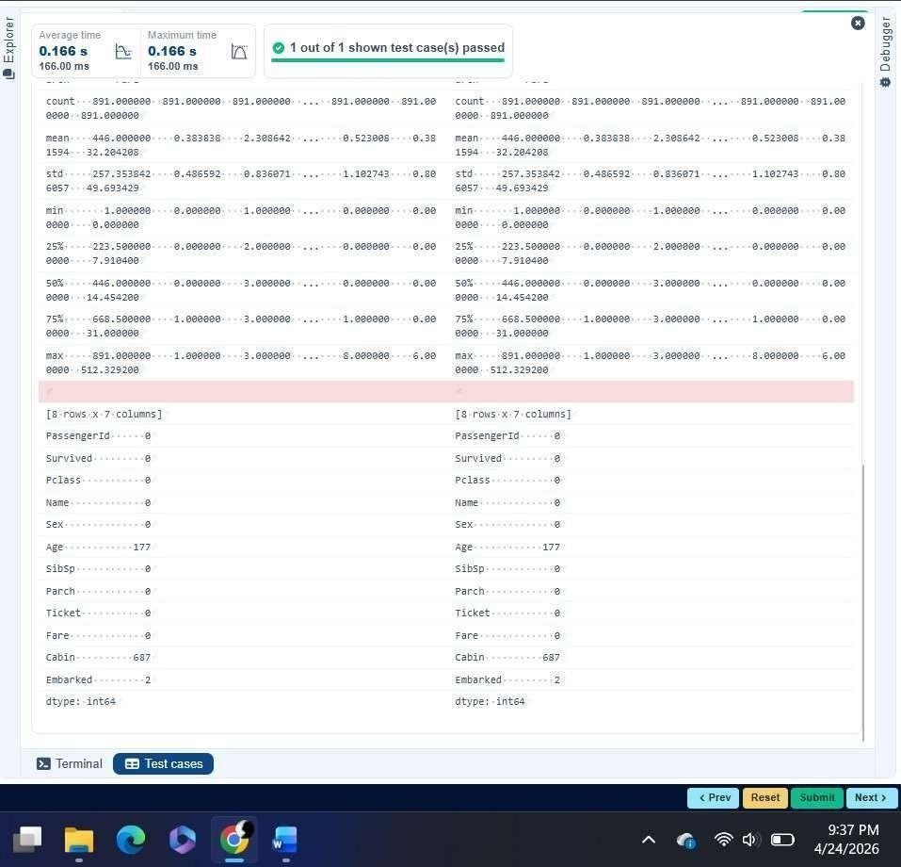
4.2.6. Titanic Dataset Analysis and Data Cleaning - 2
02:18
You are provided with the Titanic dataset containing information about passengers on the Titanic. Your task is to write Python code to answer the following questions based on the dataset.
- Create a new column ‘IsAlone’ which is 1 if the passenger is alone (FamilySize = 0), otherwise 0.
- Convert the ‘Sex' column to numeric values (male: 0, female: 1).
- One-hot encode the ‘Embarked’ column, dropping the first category.
- Get the mean age of passengers.
- Get the median fare of passengers.
- Get the number of passengers by class.
- Get the number of passengers by gender.
PassengerId | Survived | Pclass | Name | Sex | Age | SibSp | Parch | Ticket | Fare | Cabin | Embark
- Get the number of passengers by survival status.

- Calculate the survival rate of passengers.
10.Calculate the survival rate by gender.

The Titanic dataset contains columns as shown below,

Sample Data:
PassengerId,Survived,Pclass,Name,Sex,Age,SibSp,Parch,Ticket,Fare,Cabin,Embarked
1,0,3,"Braund, Mr. Owen Harris",male,22,1,0,A/5 21171,7.25,,S
2,1,1,"Cumings, Mrs. John Bradley (Florence Briggs Thayer)",female,38,1,0,PC
17599,71.2833,C85,C
3,1,3,"Heikkinen, Miss. Laina",female,26,0,0,STON/O2. 3101282,7.925,,S
4,1,1,"Futrelle, Mrs. Jacques Heath (Lily May Peel)",female,35,1,0,113803,53.1,C123,S
5,0,3,"Allen, Mr. William Henry",male,35,0,0,373450,8.05,,S
6,0,3,"Moran, Mr. James",male,,0,0,330877,8.4583,,Q
7,0,1,"McCarthy, Mr. Timothy J",male,54,0,0,17463,51.8625,E46,S
8,0,3,"Palsson, Master. Gosta Leonard",male,2,3,1,349909,21.075,,S
9,1,3,"Johnson, Mrs. Oscar W (Elisabeth Vilhelmina
Berg)",female,27,0,2,347742,11.1333,,S
10,1,2,"Nasser, Mrs. Nicholas (Adele Achem)",female,14,1,0,237736,30.0708,,C

Note: Refer to the visible test case for better reference.

import pandas as pd import numpy as np

# Load the Titanic dataset data = pd.read_csv('Titanic- Dataset.csv') data['FamilySize'] = data['SibSp'] + data['Parch'] # 1. Create a new column ‘IsAlone' (1 if alone, 0 otherwise) data['IsAlone'] = np.where(data['FamilySize'] == 0, 1, 0)

# 2. Convert ‘Sex' to numeric (male: 0, female: 1) data['Sex'] = data['Sex'].map({'male': 0, 'female': 1})

# 3. One-hot encode the ‘Embarked' column data = pd.get_dummies(data, columns=['Embarked'], drop_first=True)

# 4. Get the mean age of passengers print(data['Age'].mean())

# 5. Get the median fare of passengers print(data['Fare'].median())
# 6. Get the number of passengers by class print(data['Pclass'].value_counts())

# 7. Get the number of passengers by gender print(data['Sex'].value_counts())

# 8. Get the number of passengers by survival status print(data['Survived'].value_counts())

# 9. Calculate the survival rate print(data['Survived'].mean())

# 10. Calculate the survival rate by gender print(data.groupby('Sex')['Survived'].mean())
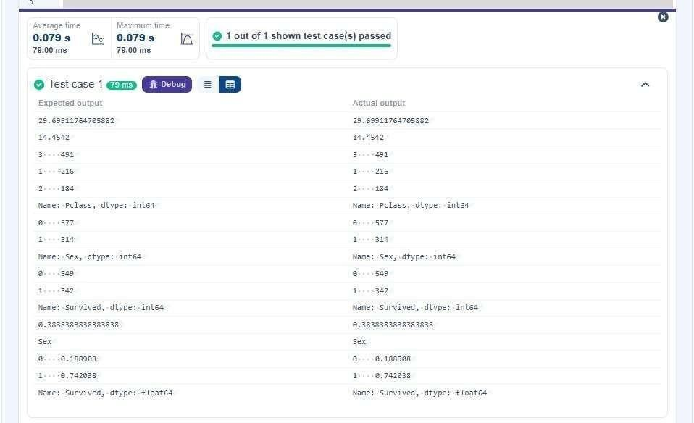
4.2.7. Titanic Dataset Analysis and Data Cleaning - 3
03:10
You are provided with the Titanic dataset containing information about passengers on the Titanic. Your task is to write Python code to answer the following questions based on the dataset.
- Calculate the survival rate by class.
- Calculate the survival rate by embarkation location (Embarked_S).
- Calculate the survival rate by family size (FamilySize).
- Calculate the survival rate by being alone (IsAlone).
- Get the average fare by passenger class (Pclass).
- Get the average age by passenger class (Pclass).
- Get the average age by survival status (Survived).
- Get the average fare by survival status (Survived).
- Get the number of survivors by class (Pclass).
- Get the number of non-survivors by class (Pclass).

The Titanic dataset contains columns as shown below,

PassengerId | Survived | Pclass | Name | Sex | Age | SibSp | Parch | Ticket | Fare | Cabin | Embark
Sample Data:
PassengerId,Survived,Pclass,Name,Sex,Age,SibSp,Parch,Ticket,Fare,Cabin,Embarked
1,0,3,"Braund, Mr. Owen Harris",male,22,1,0,A/5 21171,7.25,,S
2,1,1,"Cumings, Mrs. John Bradley (Florence Briggs Thayer)",female,38,1,0,PC 17599,71.2833,C85,C
3,1,3,"Heikkinen, Miss. Laina",female,26,0,0,STON/O2. 3101282,7.925,,S
4,1,1,"Futrelle, Mrs. Jacques Heath (Lily May Peel)",female,35,1,0,113803,53.1,C123,S

5,0,3,"Allen, Mr. William Henry",male,35,0,0,373450,8.05,,S
6,0,3,"Moran, Mr. James",male,,0,0,330877,8.4583,,Q
7,0,1,"McCarthy, Mr. Timothy J",male,54,0,0,17463,51.8625,E46,S
8,0,3,"Palsson, Master. Gosta Leonard",male,2,3,1,349909,21.075,,S
9,1,3,"Johnson, Mrs. Oscar W (Elisabeth Vilhelmina
Berg)",female,27,0,2,347742,11.1333,,S
10,1,2,"Nasser, Mrs. Nicholas (Adele Achem)",female,14,1,0,237736,30.0708,,C

Note: Refer to the visible test case for better reference.
import pandas as pd
import numpy as np

# Load the Titanic dataset data = pd.read_csv('Titanic-Dataset.csv') data['FamilySize'] = data['SibSp'] + data['Parch'] data['IsAlone'] = np.where(data['FamilySize'] > 0, 0, 1) data = pd.get_dummies(data, columns=['Embarked'], drop_first=True)
# 1. Calculate the survival rate by class print(data.groupby('Pclass')['Survived'].mean())

# 2. Calculate the survival rate by embarked location print(data.groupby('Embarked_S')['Survived'].mean())

# 3. Calculate the survival rate by family size print(data.groupby('FamilySize')['Survived'].mean())

# 4. Calculate the survival rate by being alone print(data.groupby('IsAlone')['Survived'].mean())

# 5. Get the average fare by class print(data.groupby('Pclass')['Fare'].mean())

# 6. Get the average age by class print(data.groupby('Pclass')['Age'].mean())

# 7. Get the average age by survival status print(data.groupby('Survived')['Age'].mean()) # 8. Get the average fare by survival status print(data.groupby('Survived')['Fare'].mean())

# 9. Get the number of survivors by class print(data[data['Survived'] == 1]['Pclass'].value_counts())

# 10. Get the number of non-survivors by class
print(data[data['Survived'] == 0]['Pclass'].value_counts())
